On exam 5 slides, each slide 4-6 questions
No ECG will come on slide show
-DR.sofi
SLIDE 1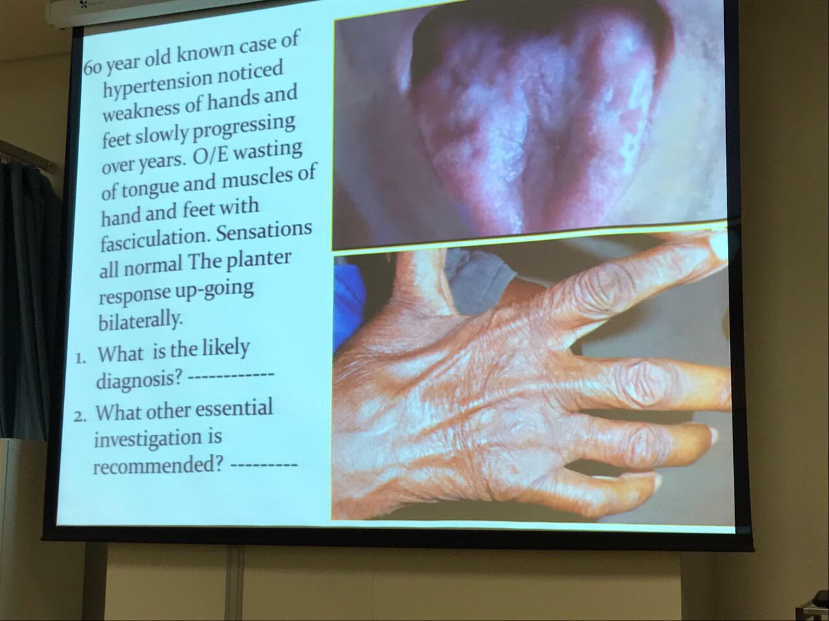
- ALS
- NERVE CONDUCTION TEST

SLIDE 2
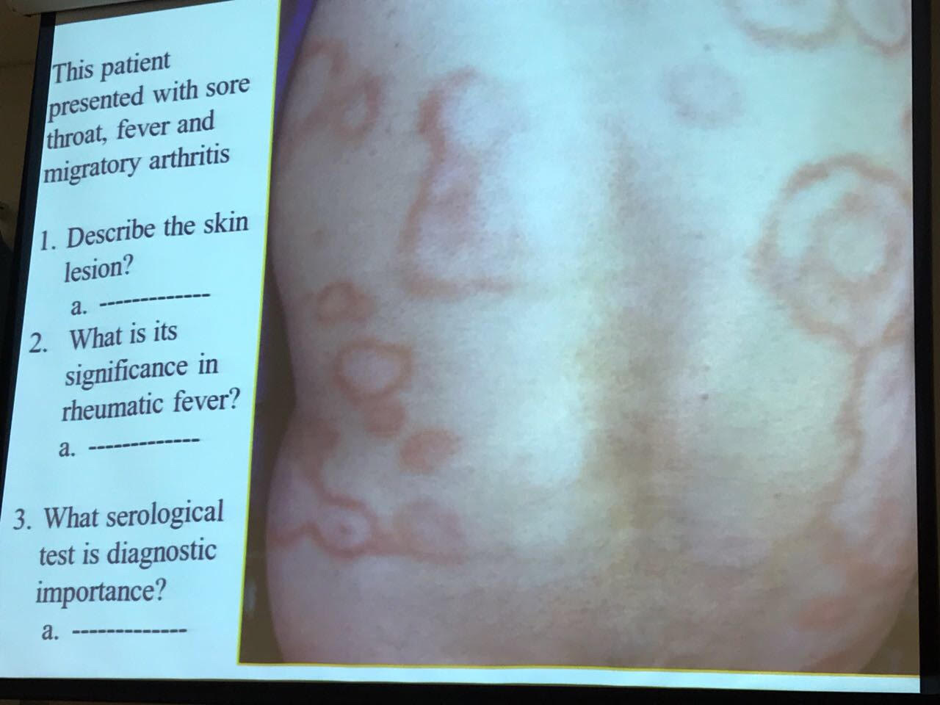
- central hallow lesions with raised margins and rash around it "Erythema magrinatum"
- It's a major criteria for Rh fever.
- ASO Antibody (Raised) and AntiDNA

SLIDE 3
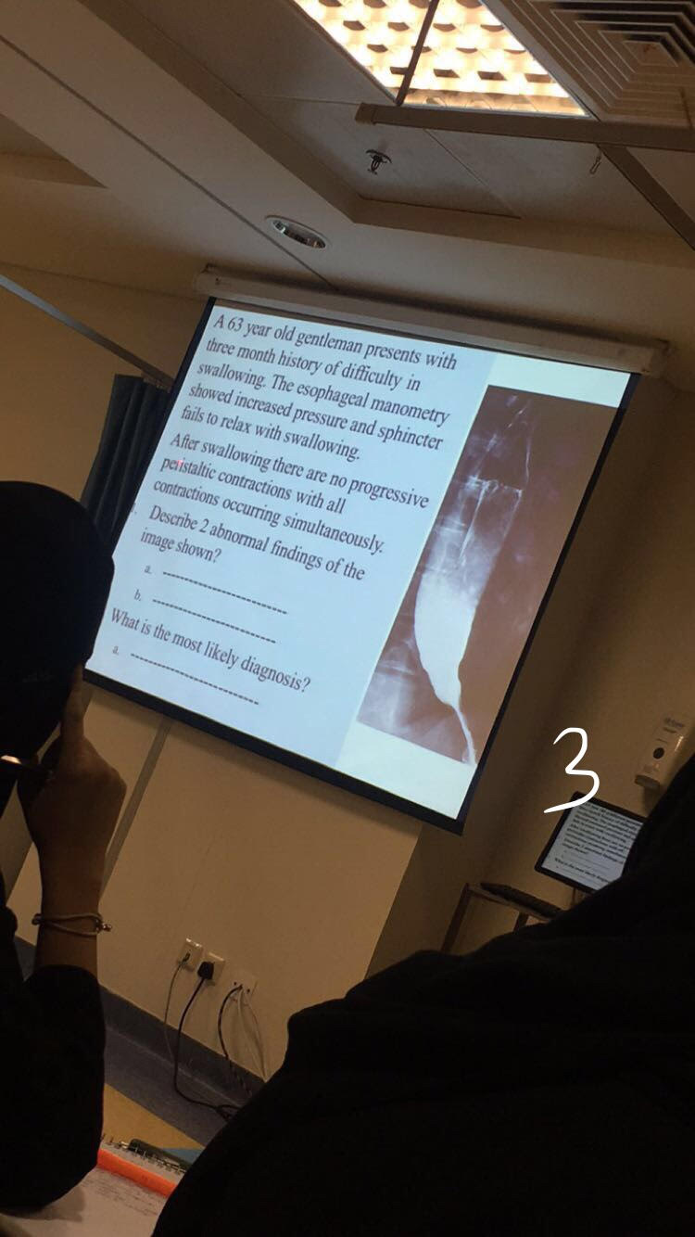
- dilate esophagus and Stricture of lower esophagus sphincter.
- Achalasia

3(extra Q) complication: Pnumonia

SLIDE 4
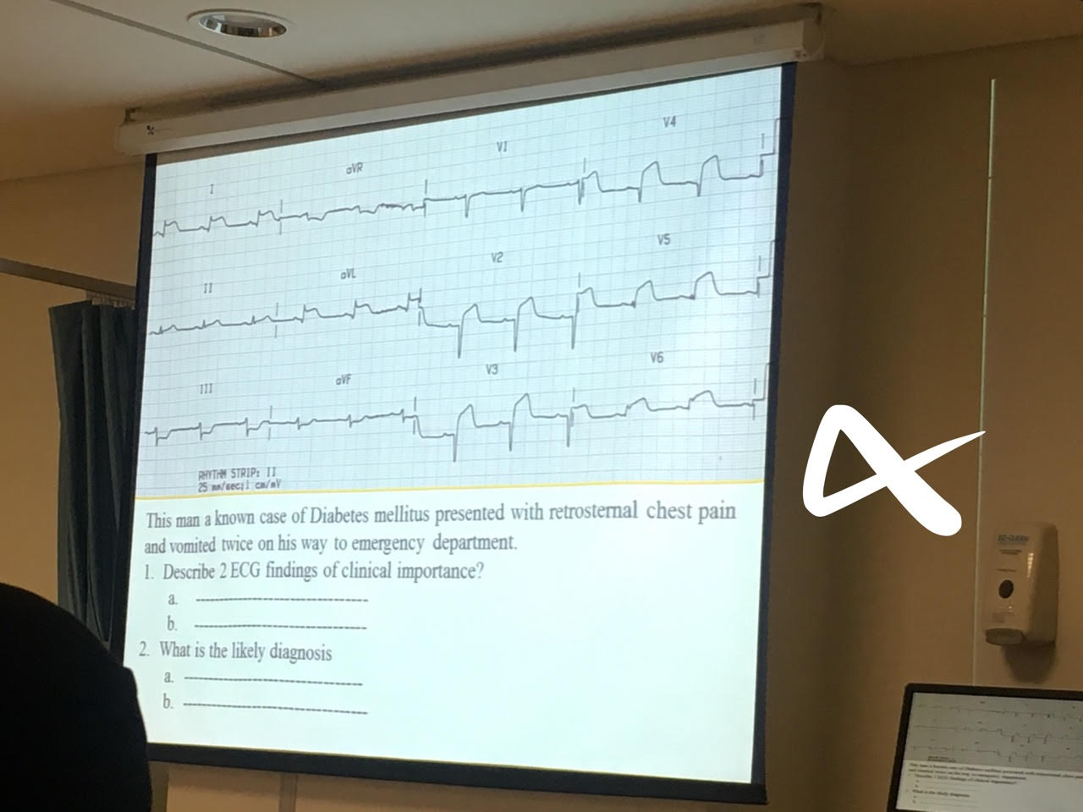

- ST elevation on lead 1 and 2, lead 3 restrictive changes with lead 1.
- Anterior lateral MI - Pericarditis

SLIDE 5
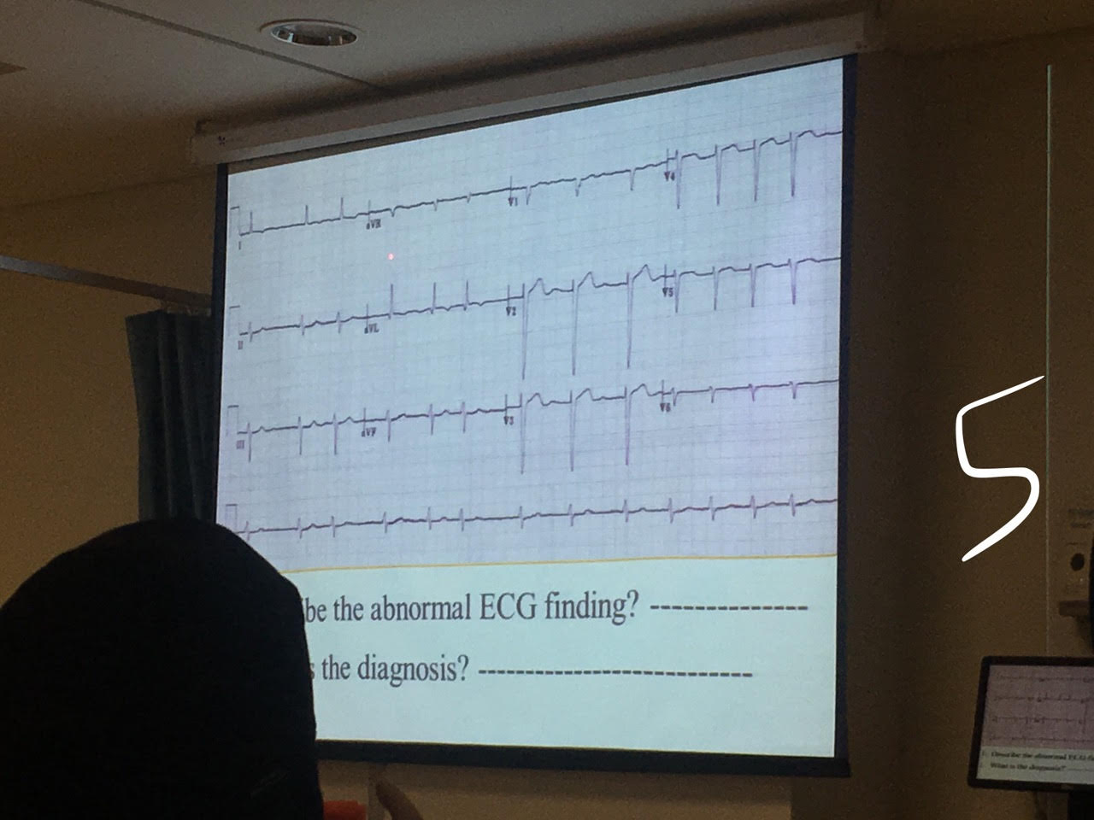
- No P wave- irregular irregular
- Atrial fibrillation

SLIDE 6
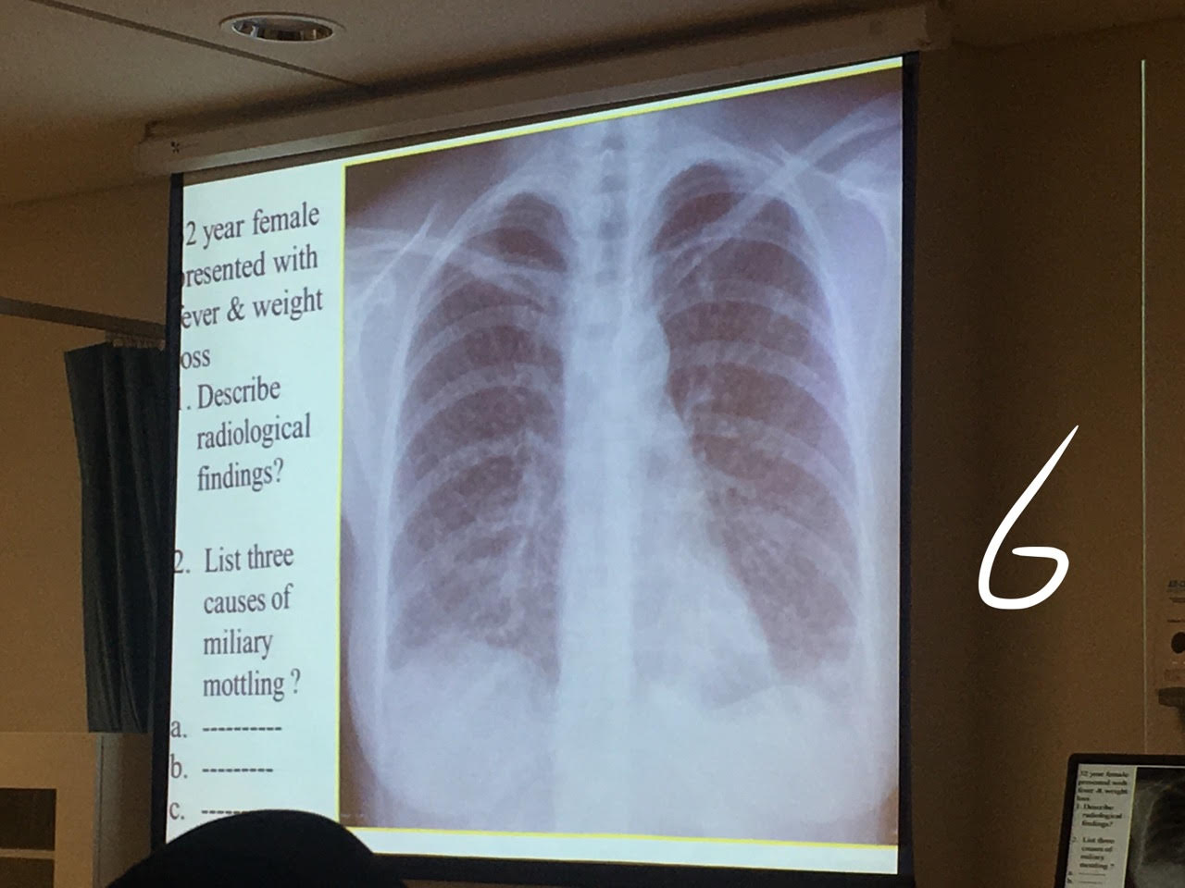
- Infiltrative lungs.
- TB - sarcoidosis - metastatic lesions.

SLIDE 7
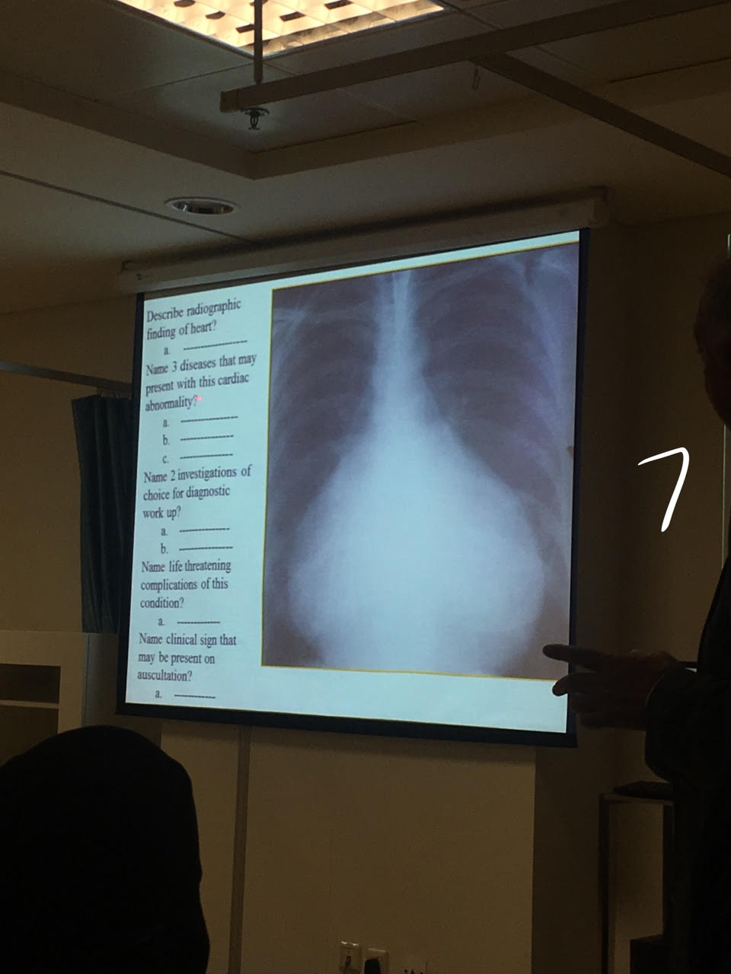
- Cardiomegaly
- Pericarditis -SLE- Rheumatoid arthritis - malignant pancarditis.
- Echo - CT
- Cardiac tamponade
- Pericardial friction rub

SLIDE 8
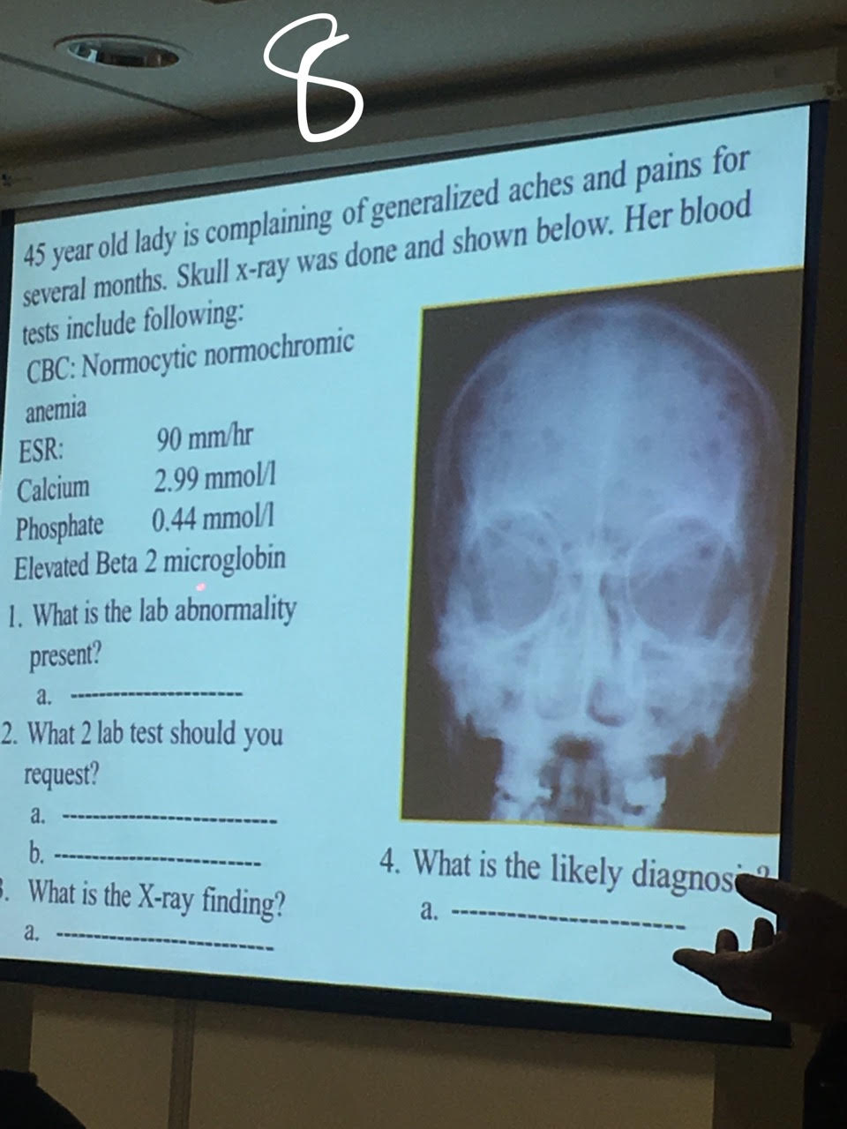
- High ESR and Ca - elevated Beta 2 microglobin which is diagnostic for multiple myeloma.
- Urine we will find "BENCE JONES PROTEIN"
- Lytic lesion all around the skull
- Multiple myeloma

SLIDE 9
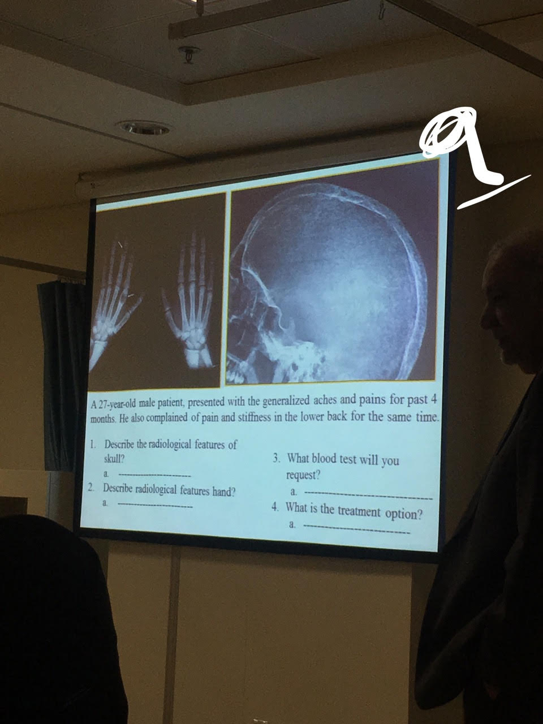
- Multiple lesion "paper and salt"
- Lytic lesion in metapharyngeal and middle finger "Brown tumor"
- Parathyroid hormone.
- Surgery "remove the tumor"

SLIDE 10
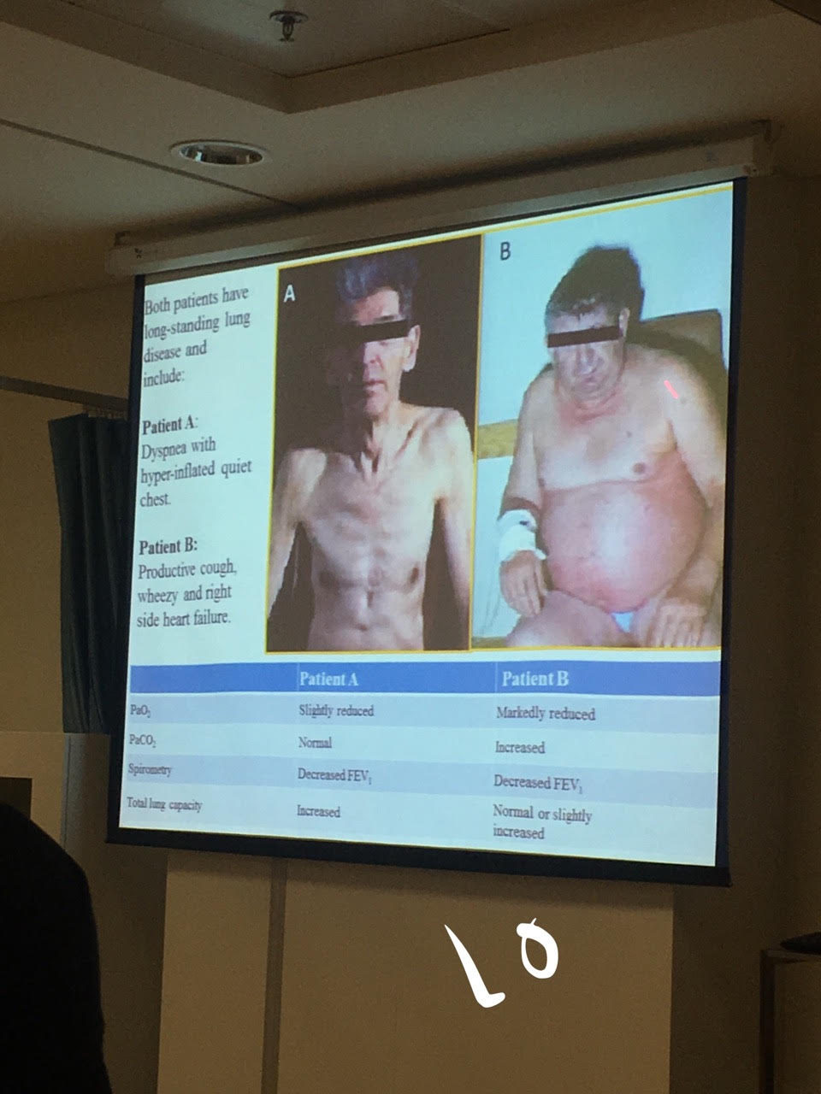
This informations + he will ask about blood gas (ABG) , Hypoxemia and Hypercapnia

SLIDE 11
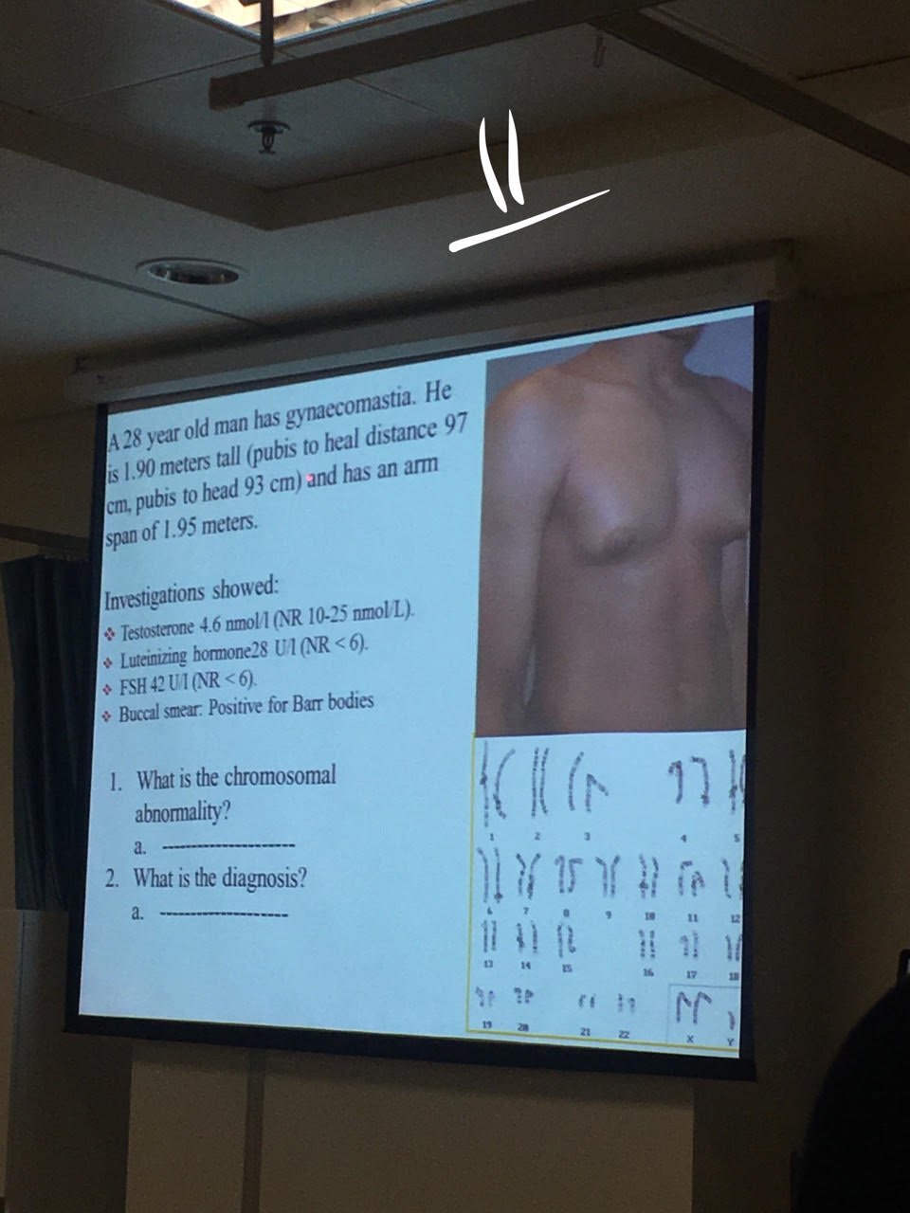
- XXY "extra X chromosomes"
- klinefelter syndrome
SLIDE 12
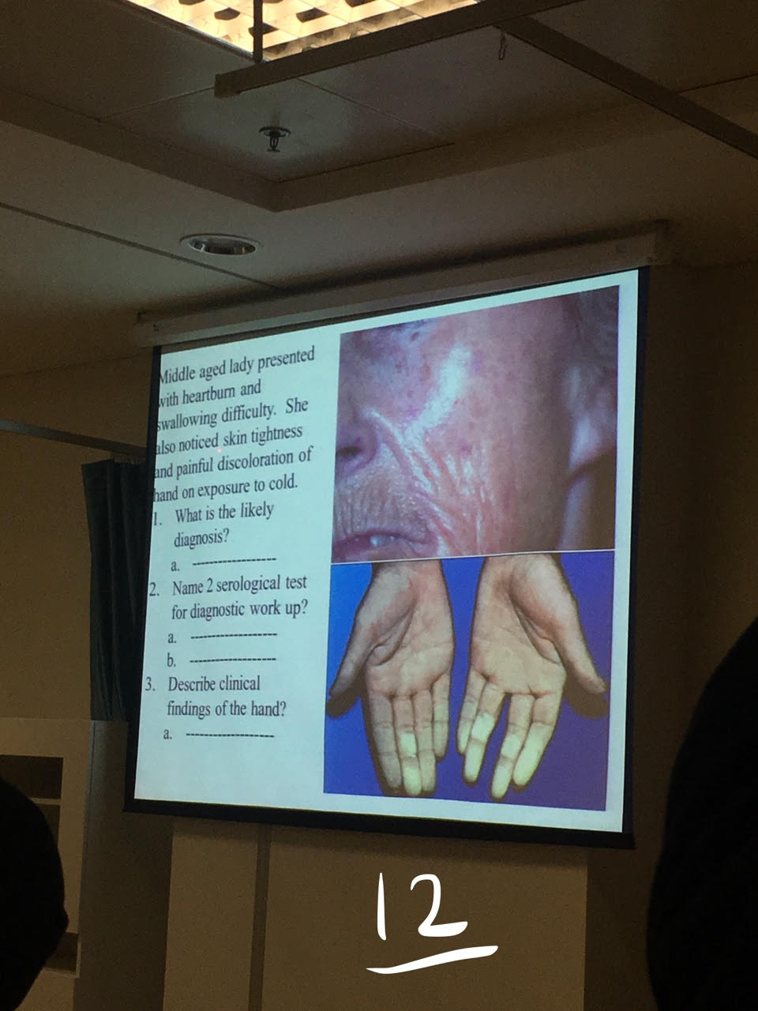
- Systemic Sclerosis (Scleroderma)
- Antiisomerase Antibody - Topoisomerase Antiboddy.
- raynaud's phenomenon
- (Extra Q) Clinical signs of this disease CREST>> Calcinosis, Raynaud's phenomenon, Esophageal dysmotility, Sclerodactyly, and Telangiectasia.

SLIDE 13
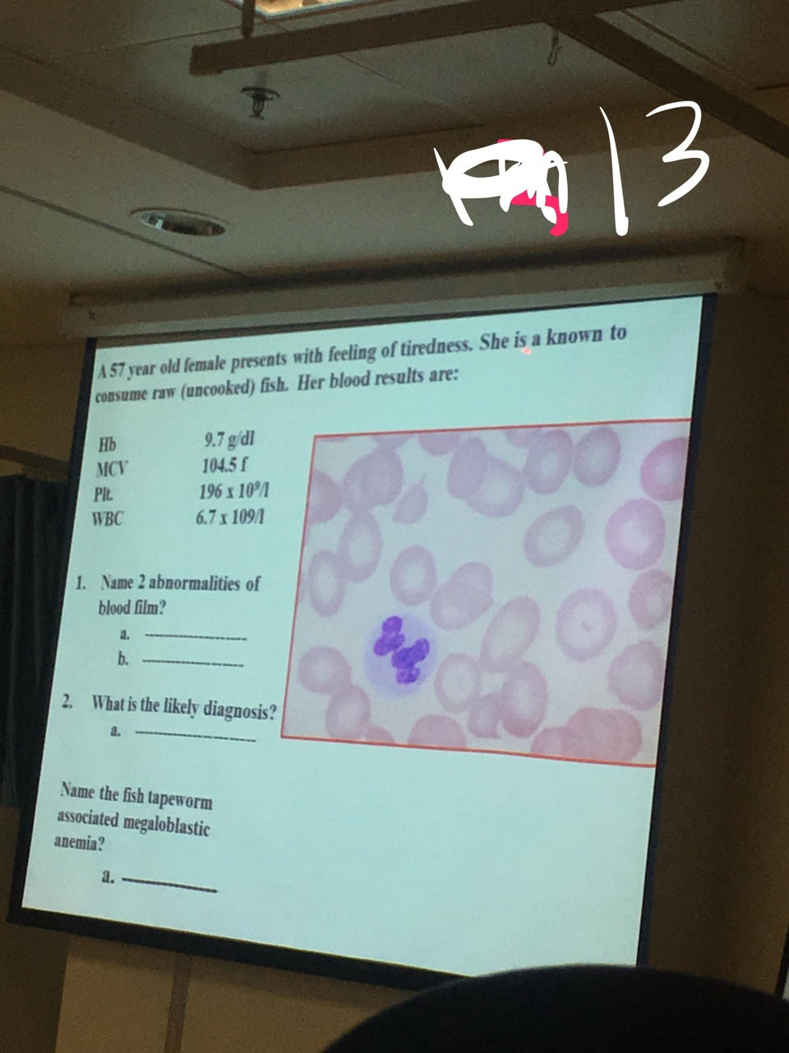
- Macrocytosis- hypersegmented neutrophil.
- pernicious Anemia.
- Diphyllobothrium latum.

SLIDE 14
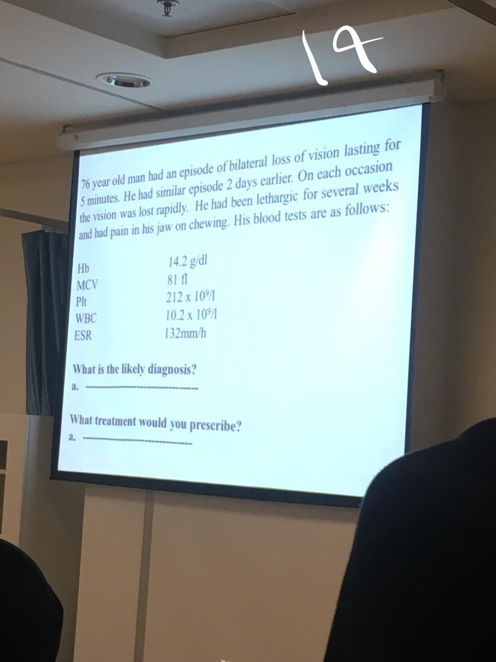
- Giant Great Arteritis
- High dose steroid 1mg daily for 5 years.
- Extra Q >> which artery? Temporal.
- Extra Q>> symptoms? Headache - generalized weakness and jaw claudication and consider High ESR.

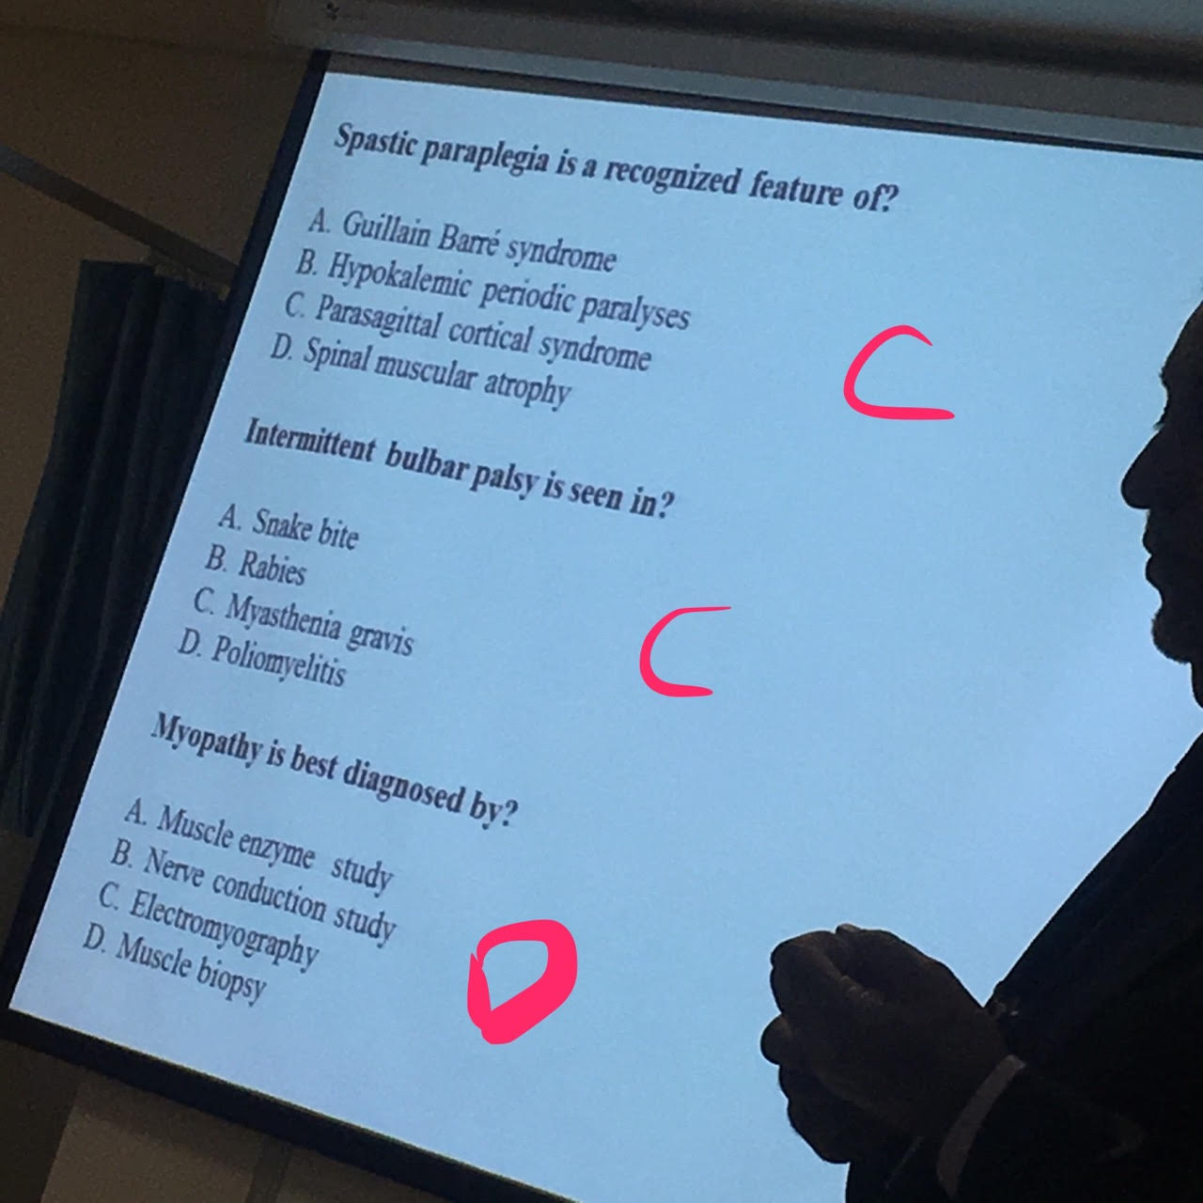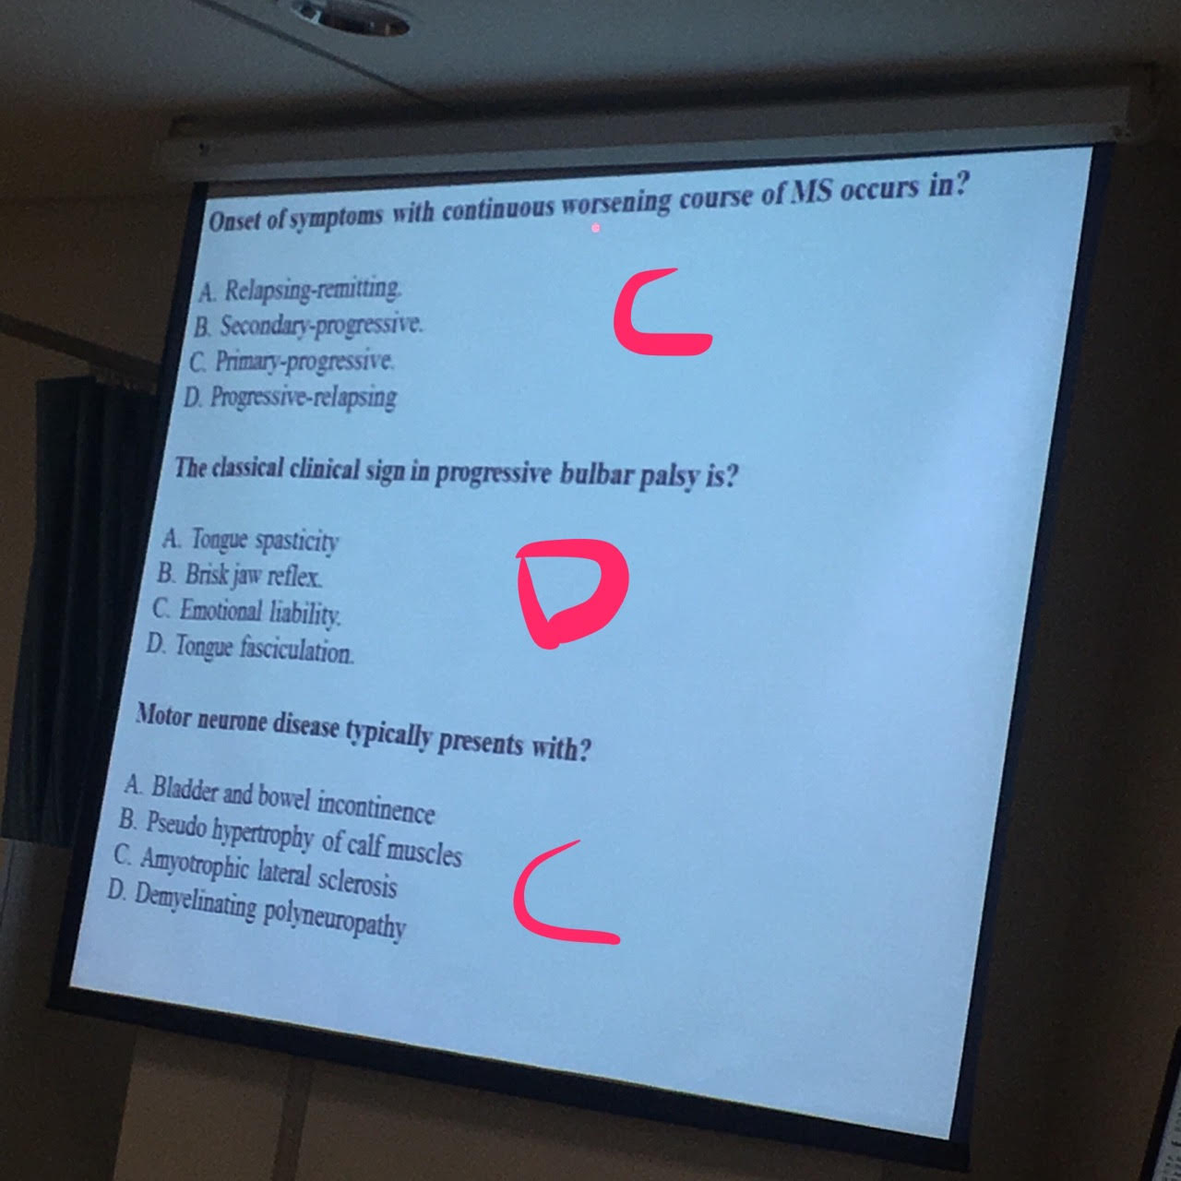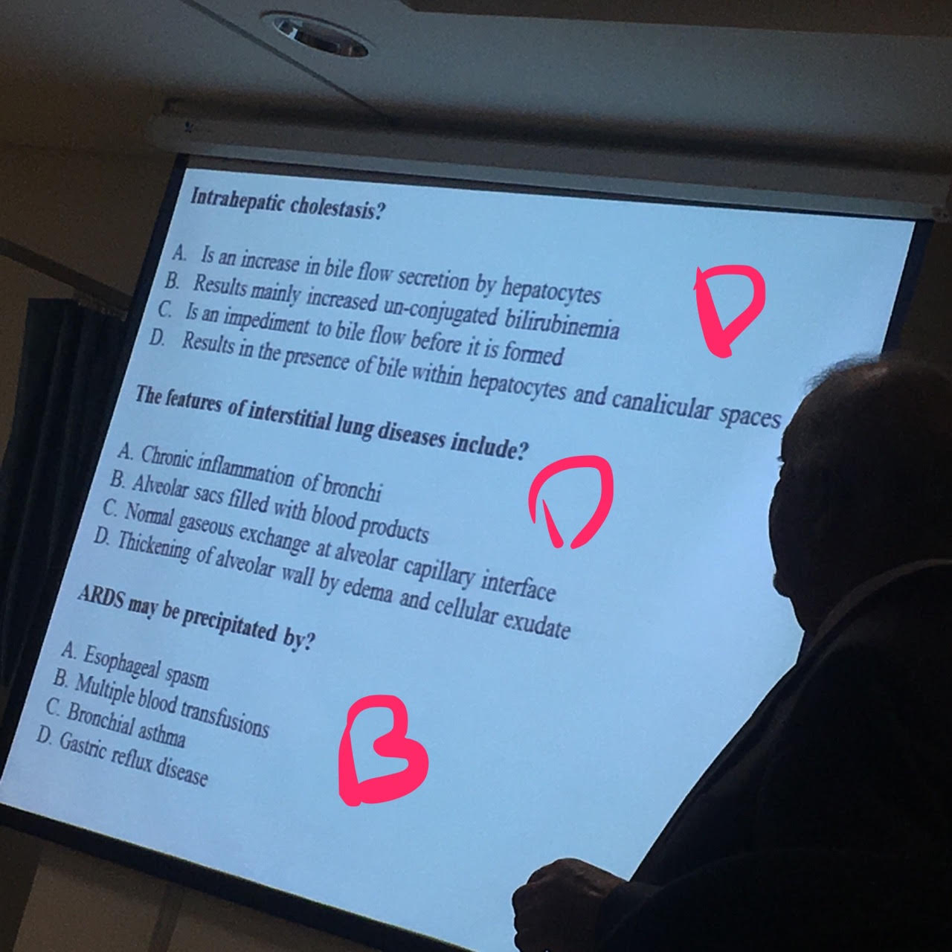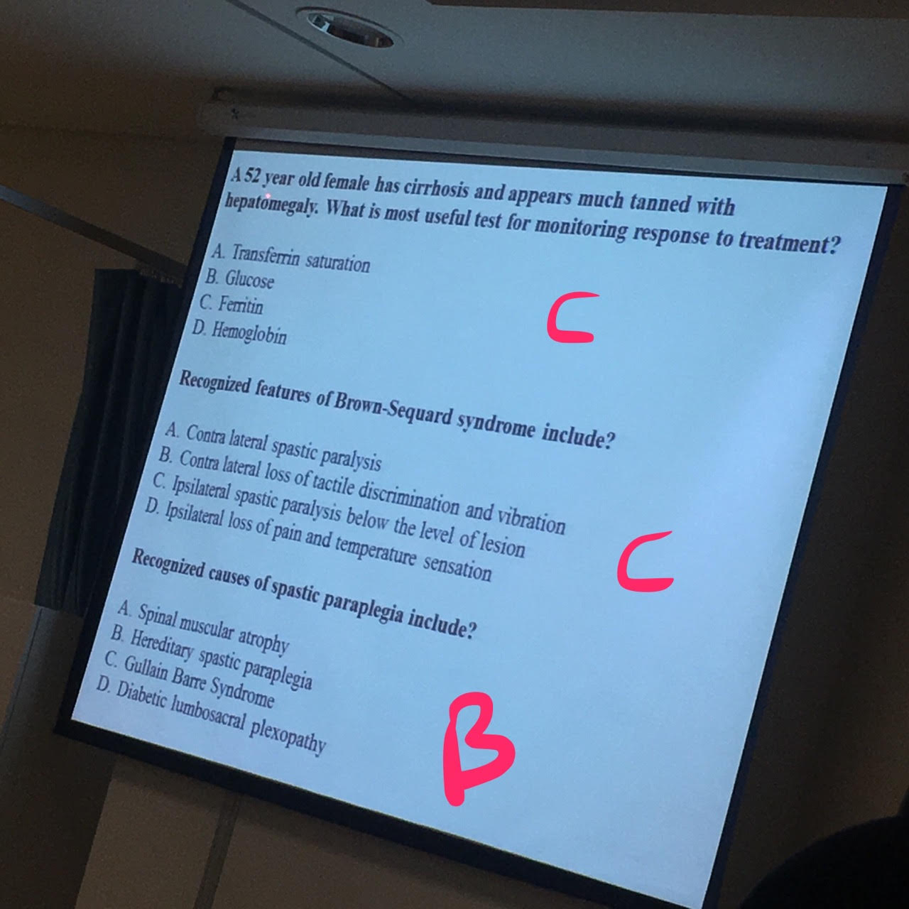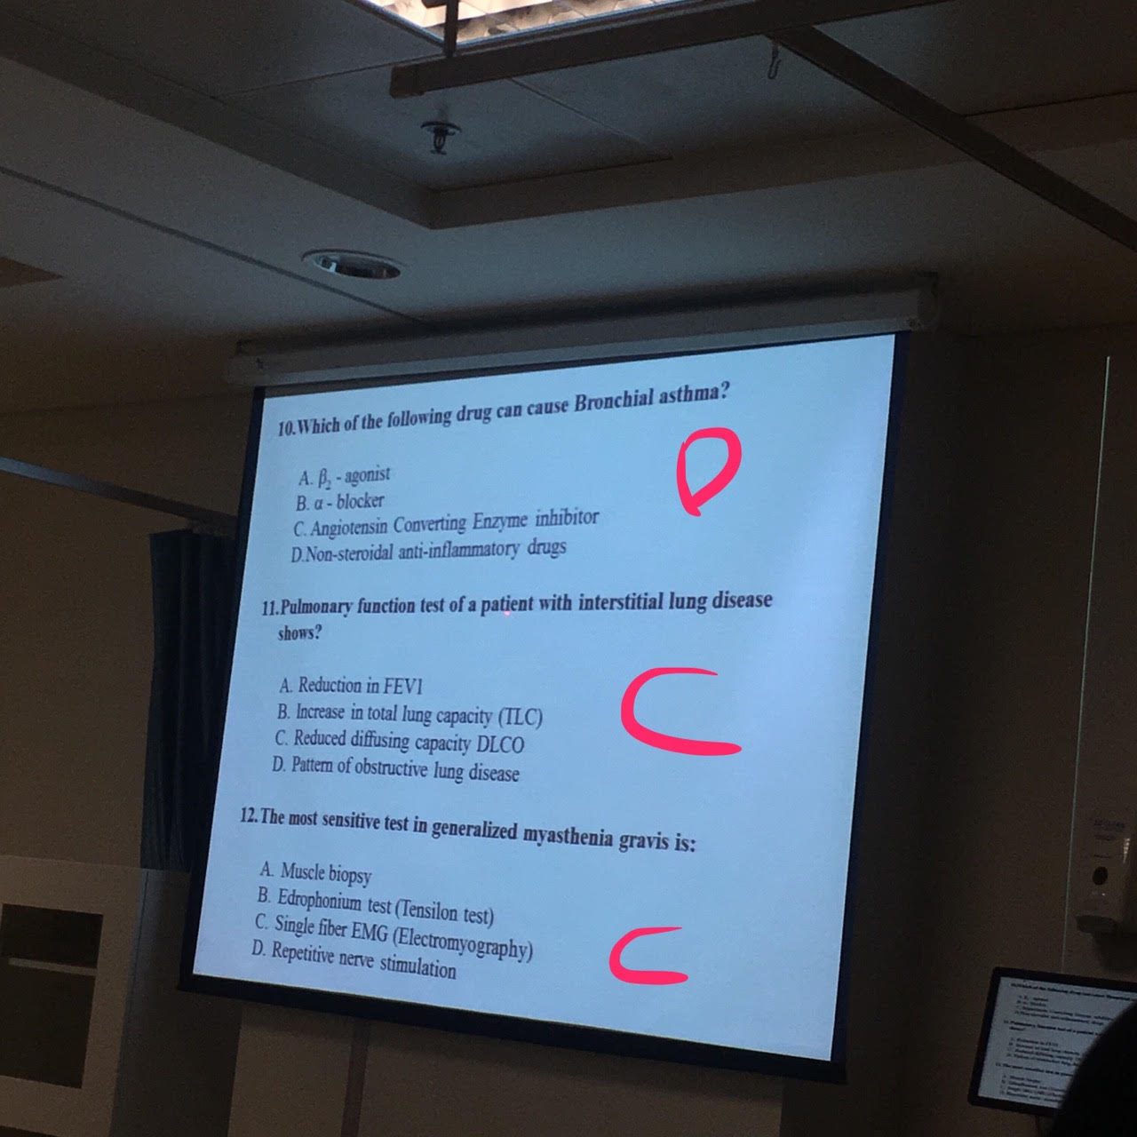

IMPORTANT note for MCQS
45 questions

ASD >> fixed splitting in second heart sound (the only Q in this lecture)

Interstetial lung disease >> hypoxemia - never get hypercapnia - it's a restrictive disease - and on X-ray you will se infiltration and fibrosis.

Rheumatic fever>> can cause Pancarditis.

ALS >> type primary progressive patient will never get remission.

ON HISTROY TAKING
CHEST PAIN
JOINT PAIN AND SWELLING (arthritis)
CHRONIC DIARRHEA
SORE THROAT
HEADACHE
GOOOOOOD LUCK GUYS ~

