Name Name | Indication | Complication | Pictures
Non tooth tissue forceps | - To hold soft tissue, muscles, peritoneum, uterus | - Injury  - Damage of soft tissue | 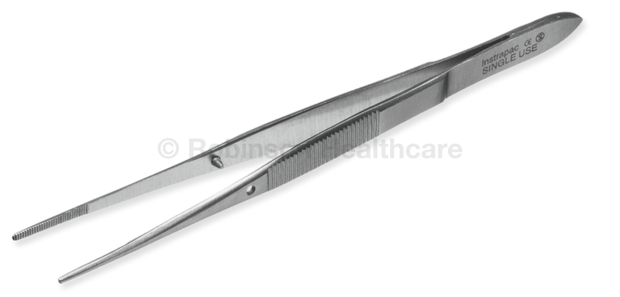
Tooth tissue forceps | - Hold tuff tissue  - Hold skin, rectus, and sheet. | - Injury  - Infection  - Damage of tissue. | 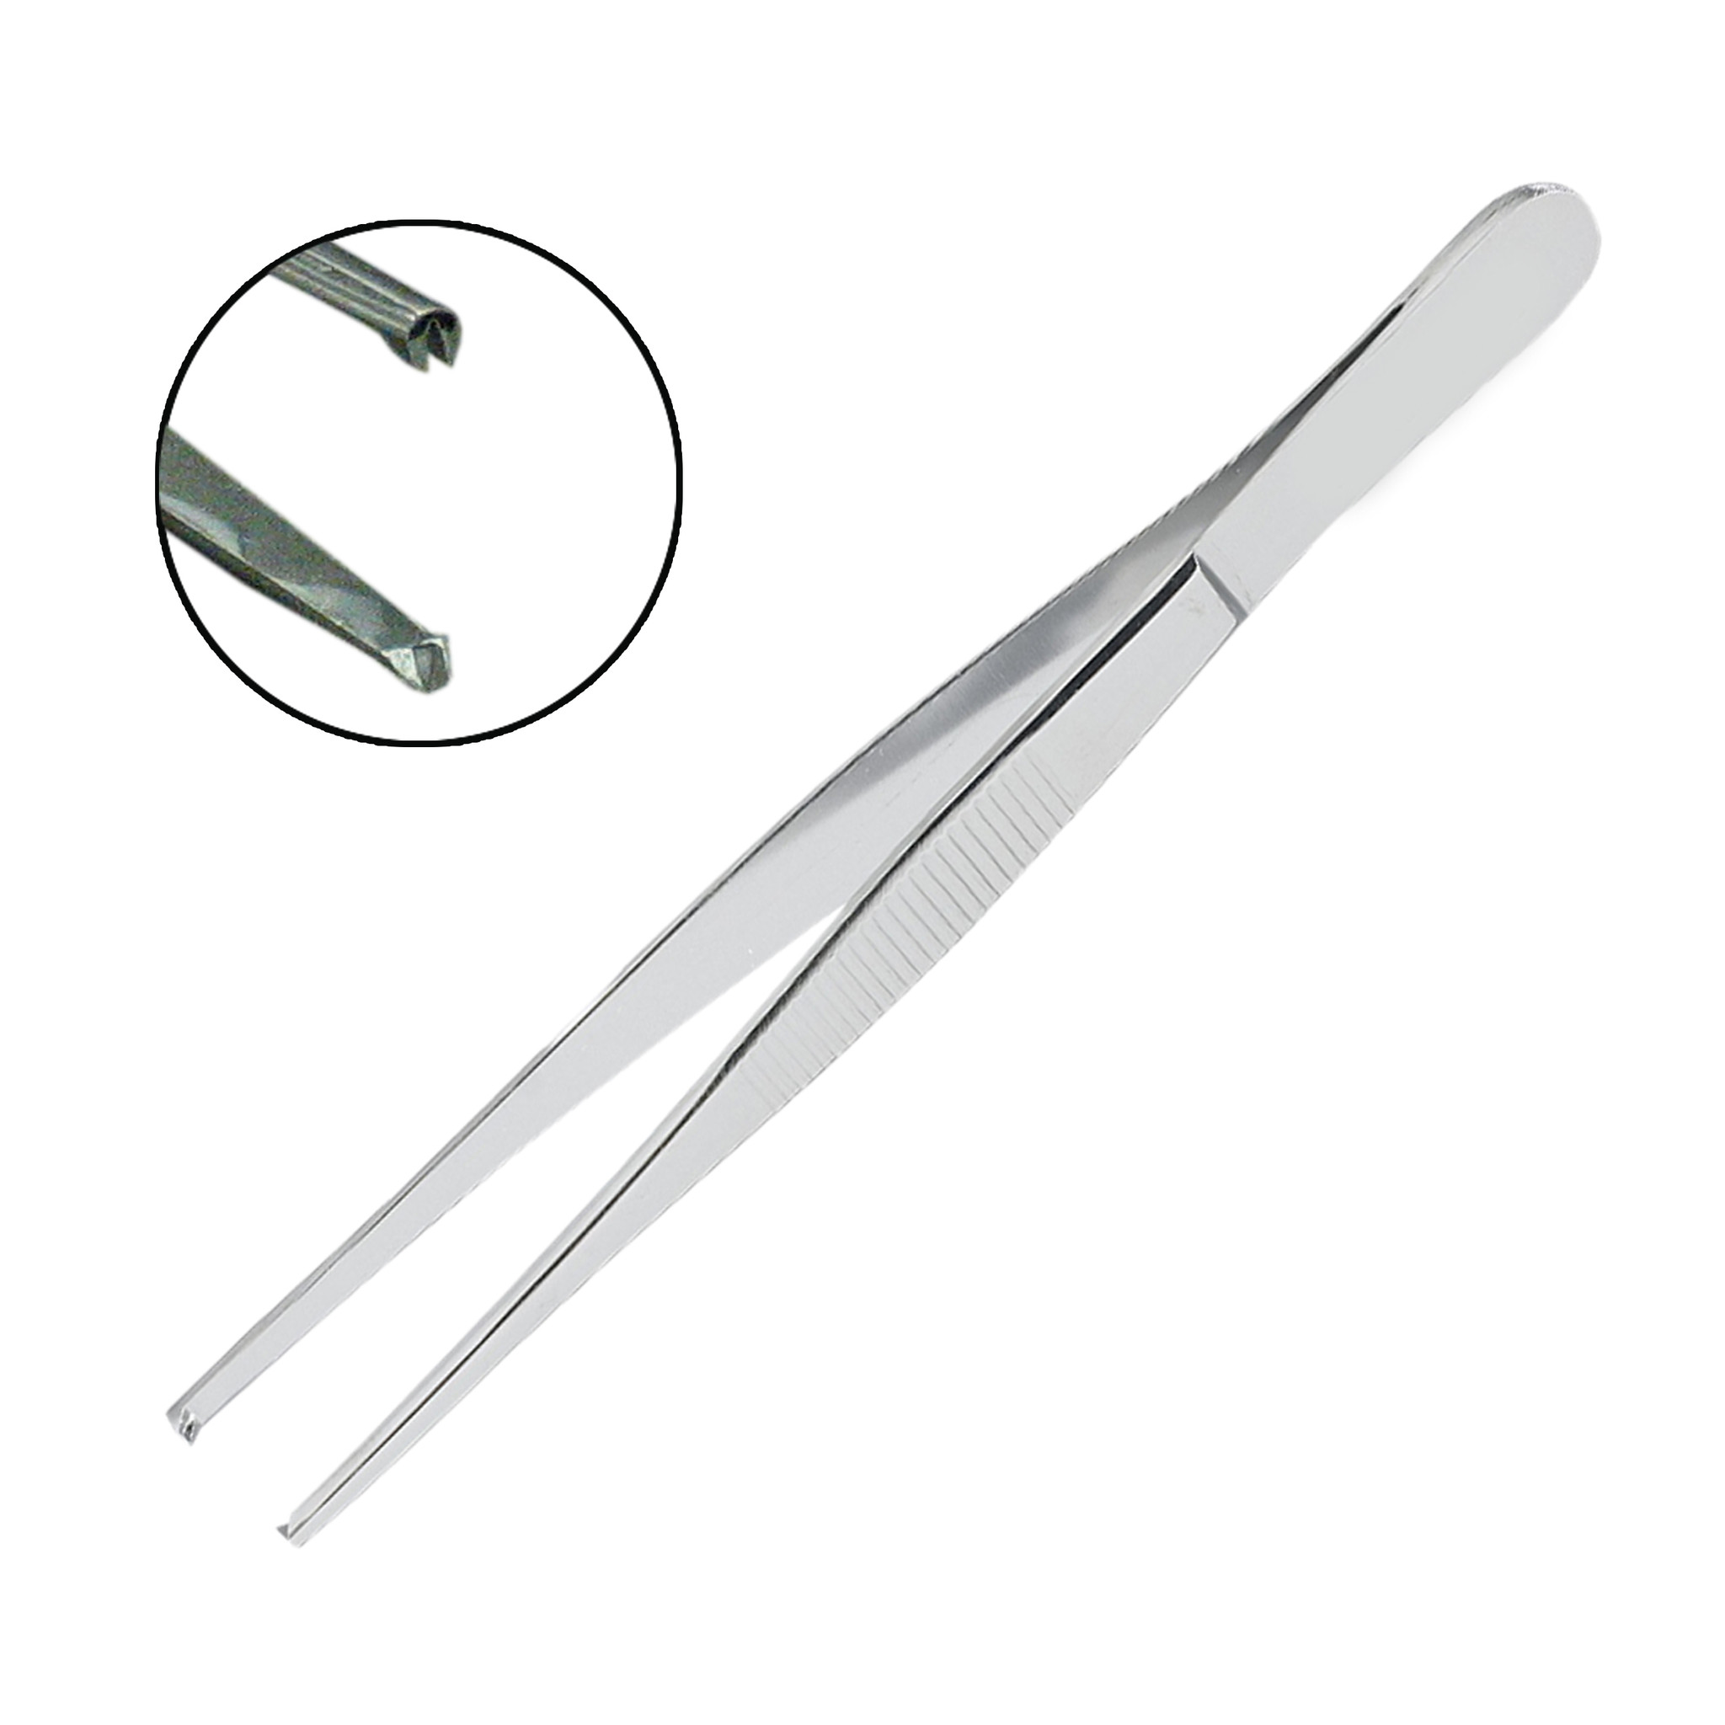
Sims & Cusco’s Speculum | - Take pap smear (Cusco’s)  - Visual cervix (Cusco’s)  - High vaginal swab (Cusco’s)  - Exam Ant. Vaginal wall and diagnose pelvic organ prolapse (Sims) | - Infection  - Pain  - Injury | 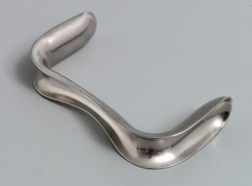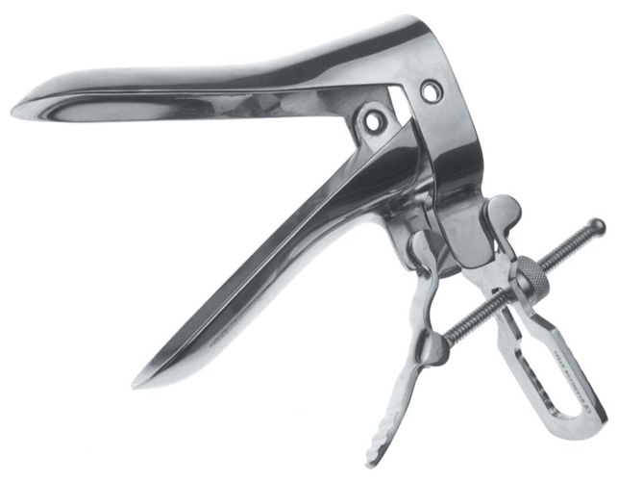
Needle holder | - To hold needle during suture | - Infection  - Injury | 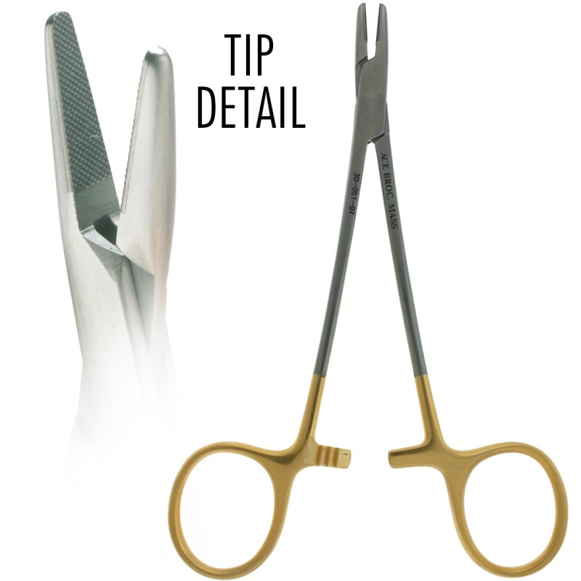
Suture | - To suture anything | - Injury
Mayo scissor  (Thick) | - To Cut tuff tissue | - Bleeding  - Injury  - Infection | 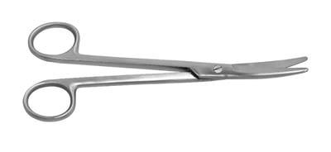
Metezenbaum scissor  (Fine)  ( | - To cut tissue | - Bleeding  - Injury - Infection | 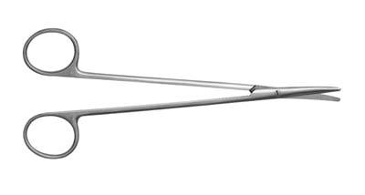
Bandage scissor | - Uterine incision ( C\S) | - Bleeding -Infection  - Injury | 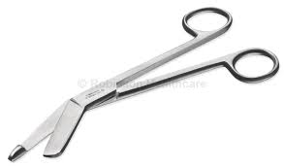
Allis forceps | - Hold tuff tissue, rectum, vaginal fold | - Injury  - Infection | 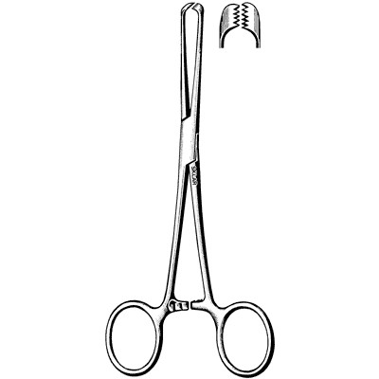
Vulsellum forceps | - To hold cervix (evacuation , hystrosalpingogram , Ant. And post. Repair | - Bleeding - Infection  - Injury | 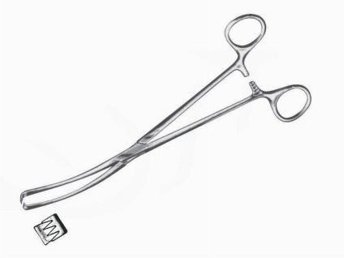
Tenaculum forceps | - To hold cervix (evacuation , hystrosalpingogram , Ant. And post. Repair | - More bleeding  - Cervical injury  - Infection | 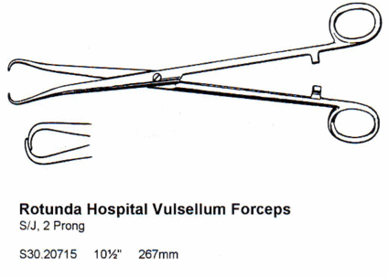
Ovum forceps | - Hold cervix  - for evacuation in abortion  - Exposure of cervix | - Infection  - Cervical & uterine injury  - Uterine perforation | 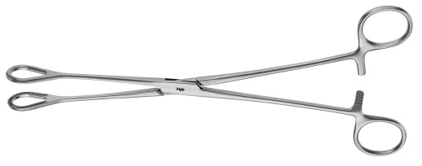
Green armytage |  | - Hold edge of uterine during C/S | 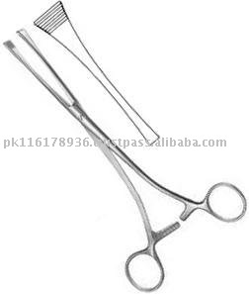
Uterine sound | - Measure uterine cavity (IUCD) | - Uterine perforation | 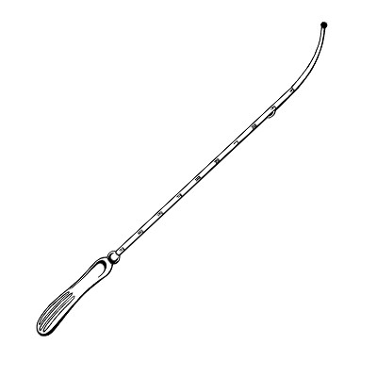
Uterine curette sharp&dull | - Evacuation in abortion  - take sample  - use with uterine sound  -for diagnostic D&C | - Bleeding  - infection  - Sherman syndrome  - uterine injury | 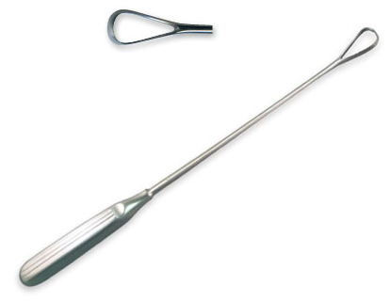
Doyen retractor | - retraction the bladder during C/S | - Pressure in bladder  - Injury | 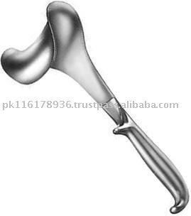
Folly’s catheter | - Urine sample  - derange urine from bladder | - Infection | 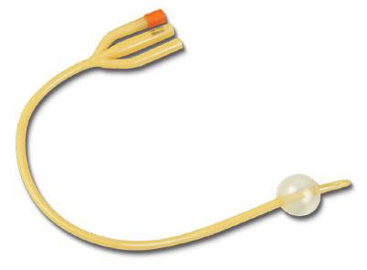
Kockers | - To hold tuff tissue (rectus sheet) |  | 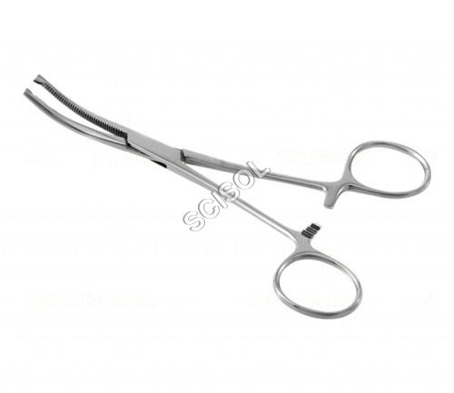
amniohook | - ROM |  | 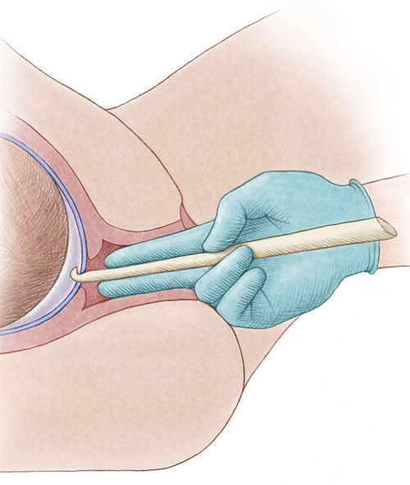
Fetal scalp electrode | - Mentoring fetal | - Injury or Infection to mother | 